It’s very important that when you start a Premiere project you understand the initial settings. To get these settings right you need to know what device you used to film the project and what settings you used in the device.
Before opening Premiere ensure that you have created a project folder in the D Drive and copied your footage into a folder within that project folder.
New Project
When you start a new project the first screen is fairly straight forward, all it really wants to know is where you want to put the project on the computer and what you want the project to be called.
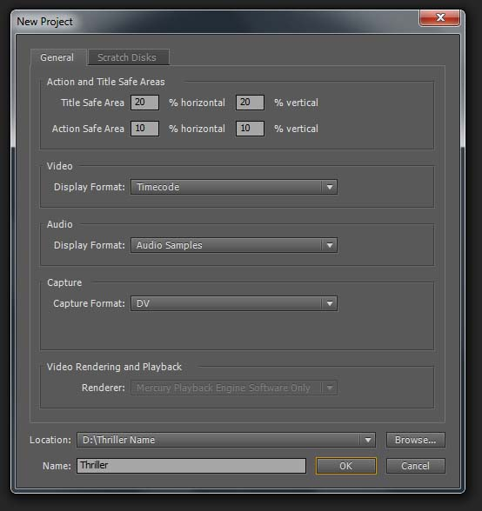
Give your project a name.
You should create a project folder in the D drive and tell Premiere to put your new project in there.
Please remember, all footage, sound, images, animations... that you use for the project should also be located in that same project folder.
New Sequence
You need to know what device / settings you recorded your footage with. Below are the two pre-sets you will need if you used Media Studies Department equipment.
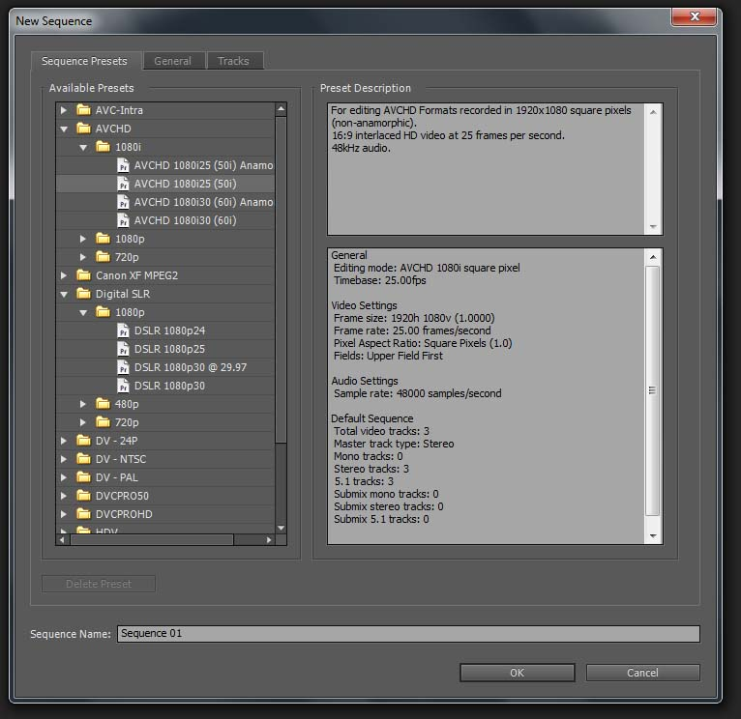
If you are using footage recorded on one of the Canon 550D SLR cameras you should use this pre-set.
If you are using footage recorded on one of the Sony HD camcorders, this is the pre-set you should select.

