1. Select **FLV/F4V**, this will export your video as a Flash Video file, which is suitable **for Youtube**.

*If you want to export* ***for DVD****, you should export as* ***‘ MPEG2’****, which retains higher quality.*

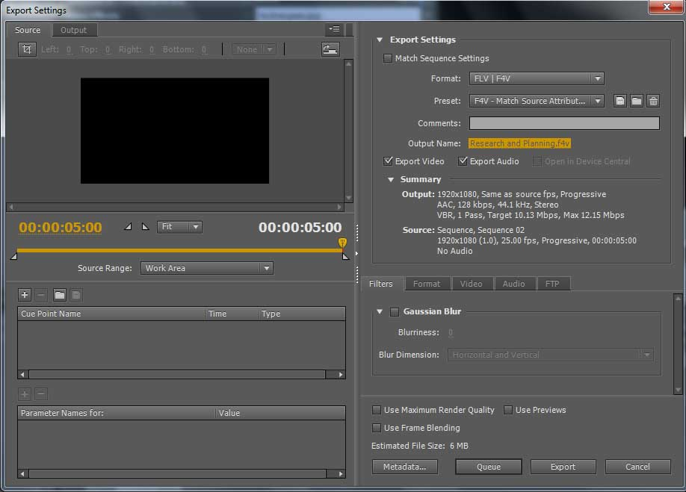

4. You can then either ‘Queue’ which you will need if you have multiple videos to export at the same time, or click **‘Export’** for the video to be exported immediately.

3. Click on this **‘Output Name’** in order to rename your video and to send it to the desired location on the D Drive.

2. The preset should ‘**Match Source Attributes’** (default). This will retain the frame size / rate. You can step this down if you are exporting for your website, blog or handheld device.